**INDUSTRIAL VISIT REPORT**

Renuka Electricals and controls.

S-72, MIDC, Industrial area

Hingna road,

Nagpur-440016.

**Introduction:**

To access the insulating property of dielectric transformer oil,a sample of transformer oil is taken and its breakdown voltage was measured. The industry had a transformer insulating oil tester machine in which the various parameters regarding oil testing is done.

**Purpose of Visit:**

The purpose of visiting the industry was to study the various parameters related about the transformer oil testing. The parameters which we studied are density, breakdown voltage (Before filtration and after filtration), resistivity, dielectric dissipation factor (tan $δ$) , etc.

Break down Voltage is the Dielectric strength of TransformerOil. A small pot filled with Oil is tested between two Electrodes and Voltage in KV is passed between them & at certain Voltage the insulation breaks.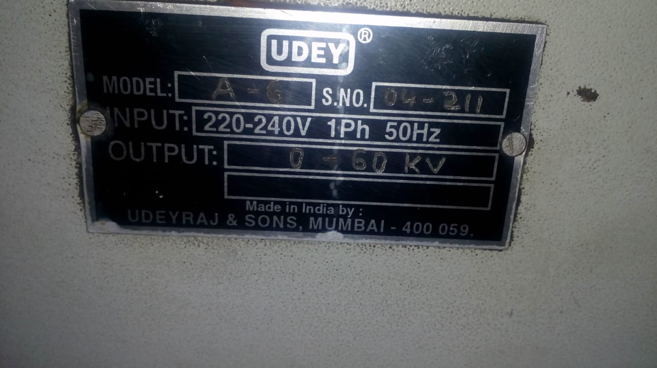

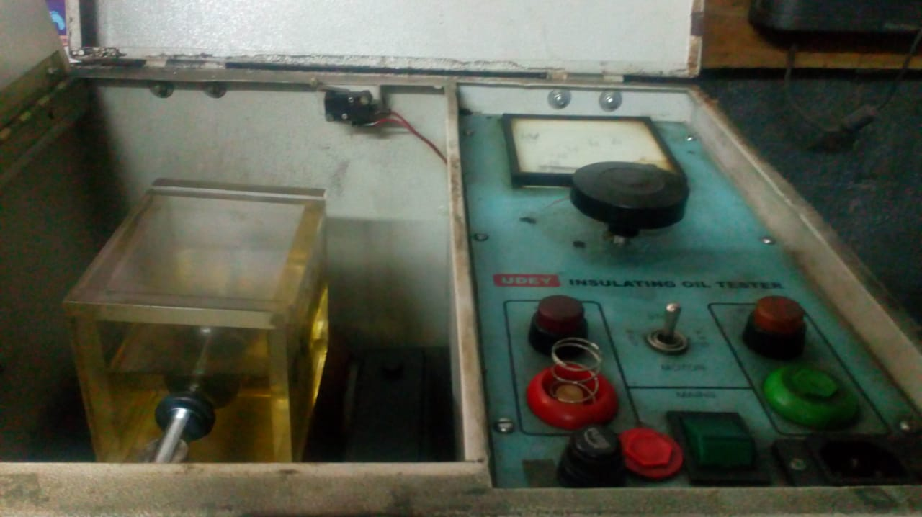

Dielectric dissipation factor is also known as loss factor or tan delta of transformer oil. As an insulating material is dielectric in nature the current through the insulation ideally leads the voltage by 90o

Following are the observations:

|  |  |  |
| --- | --- | --- |
| Sr. No. | Characteristics | Readings |
| 1. | Density at 27 deg.cel. | 0.8240 |
| 2. | BDV  a) Before filtration  b) After filtration | 30Kv(rms)  60Kv (rms) |
| 3. | Resistivity(ohm-cm) | 2.5*10^12 |
| 4. | Dielectric dissipation factor | Max-0.2  Test value:-0.0008 |

**Conclusion:**

In the industry we studied various parameters related to our practical’s, done in HV laboratory.In this way I completed the detail study of Oil testing of transformer oil.